Flowchart to Code Test Evidence
  - Introduction to Software Engineering Demo 3
Verification date 23 October 2026
The converter turns a visual even or odd algorithm into matching pseudocode, Python and browser JavaScript. The automated checks below verify the conversion pipeline, generated program behavior, API error handling and production builds.

Verification outcome
All four command checks passed with exit code 0: backend compilation, 16 backend tests, 2 frontend tests and the frontend production build. All five browser checks passed, with no browser page errors.

Evidence coverage
Backend verbose output names every pipeline and behavior test. The generated JavaScript runs with a controlled browser prompt; the generated Python runs in an actual Python interpreter. Both cover negative even input, zero and odd input. Additional checks cover shared branch continuation, invalid graphs and preservation of API validation messages.
The images include browser screenshots of captured command transcripts and direct screenshots of the running editor. Original PNG files, HTML transcripts and raw logs are preserved in docs/test-evidence. Standard output precedes standard error in each saved transcript; this can change display ordering without changing the recorded results.

Manual checks and limitations
The browser checks verified all three output tabs, clipboard content, JavaScript file download, label editing, deletion and the resulting validation message, with no page errors. Node dragging and connection editing were not exercised. The converter supports numeric input and structured acyclic flowcharts; loops and language specific expressions are outside the lesson scope.
An earlier sandbox run could not write the Jest cache. A subsequent permitted run passed. A frontend test cleanup callback initially failed type checking; the callback was corrected and the final captured build below verifies the fix.
The first browser copy assertion compared Windows clipboard CRLF text with LF text. The test harness now normalizes line endings; the subsequent copy and download checks passed. The initial browser transcript is retained as browser-smoke-initial.log.

Backend TypeScript build
npm.cmd run build --prefix backend
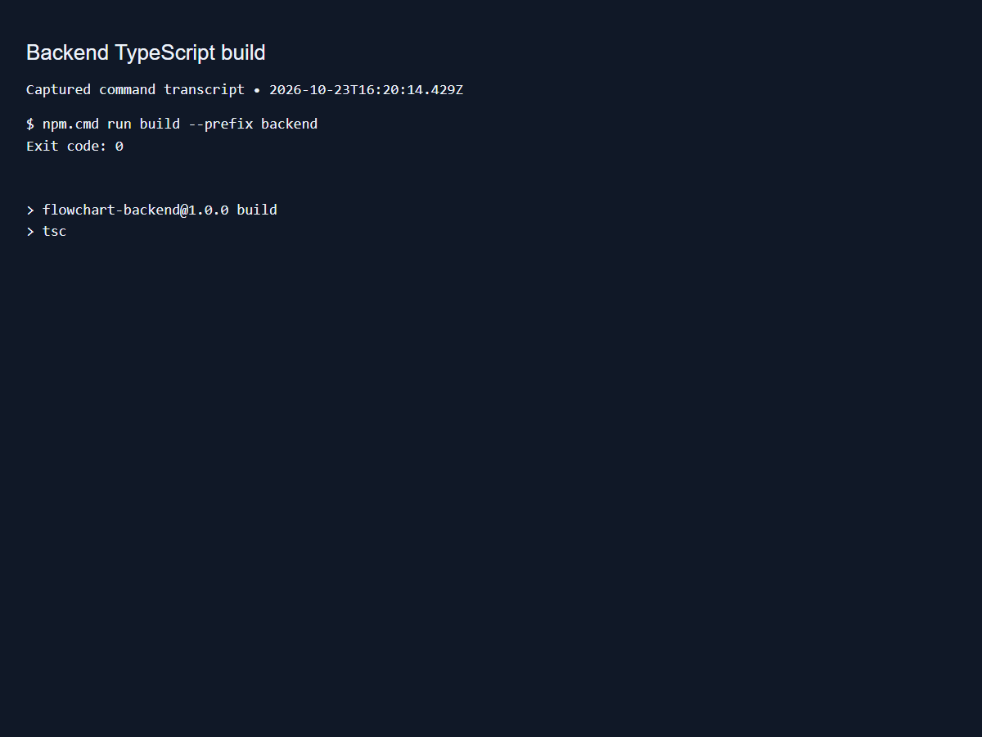
Figure 1. Command result: PASS. Source: backend-build.png.

Backend pipeline and generated program tests
npm.cmd test --prefix backend -- --runInBand --verbose
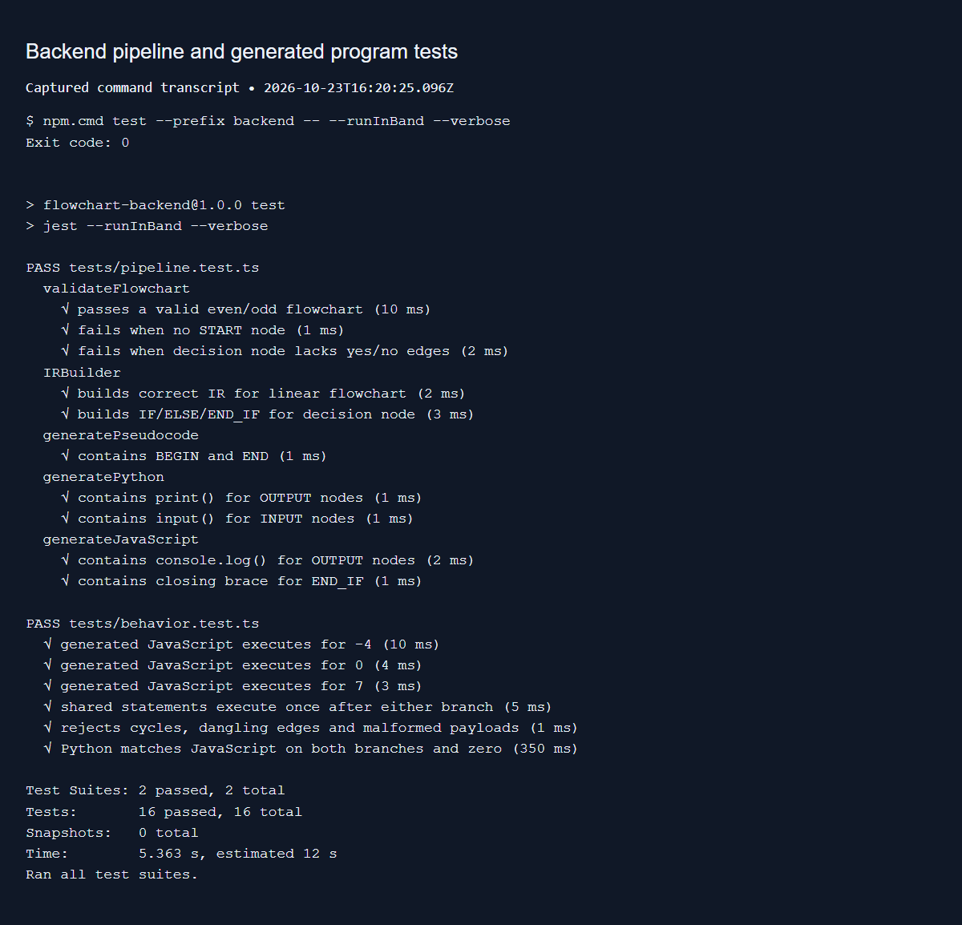
Figure 2. Command result: PASS. Source: backend-tests.png.

Frontend API error handling tests
npm.cmd test --prefix frontend -- --run --reporter=verbose
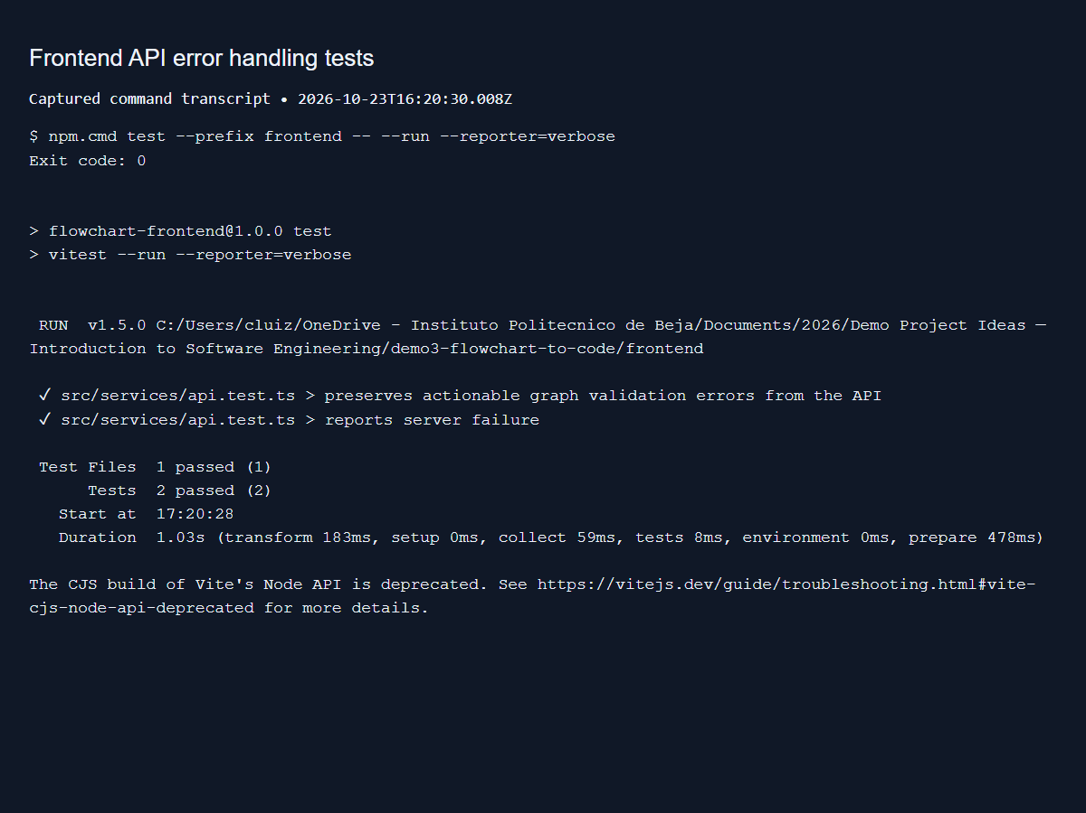
Figure 3. Command result: PASS. Source: frontend-tests.png.

Frontend production build
npm.cmd run build --prefix frontend
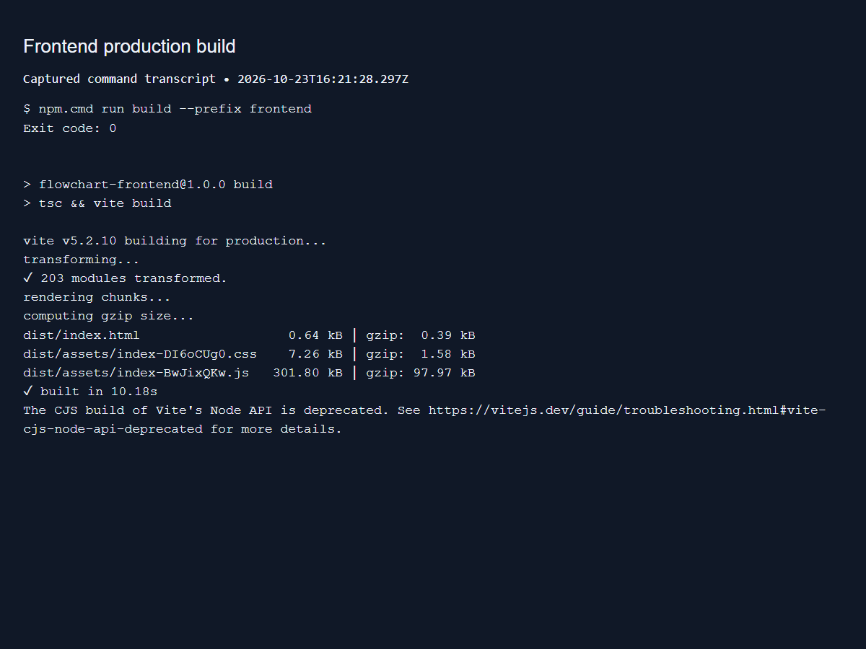
Figure 4. Command result: PASS. Source: frontend-build.png.

Starter flowchart and matching pseudocode
Automated Chromium browser smoke check
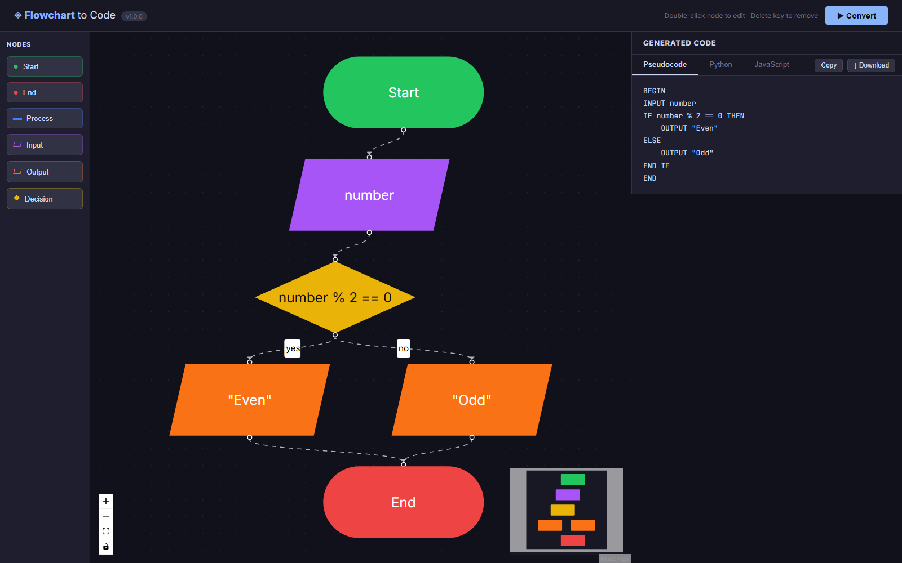
Figure 5. Browser check: PASS. Source: ui-pseudocode.png.

Python tab displays numeric input and both branches
Automated Chromium browser smoke check
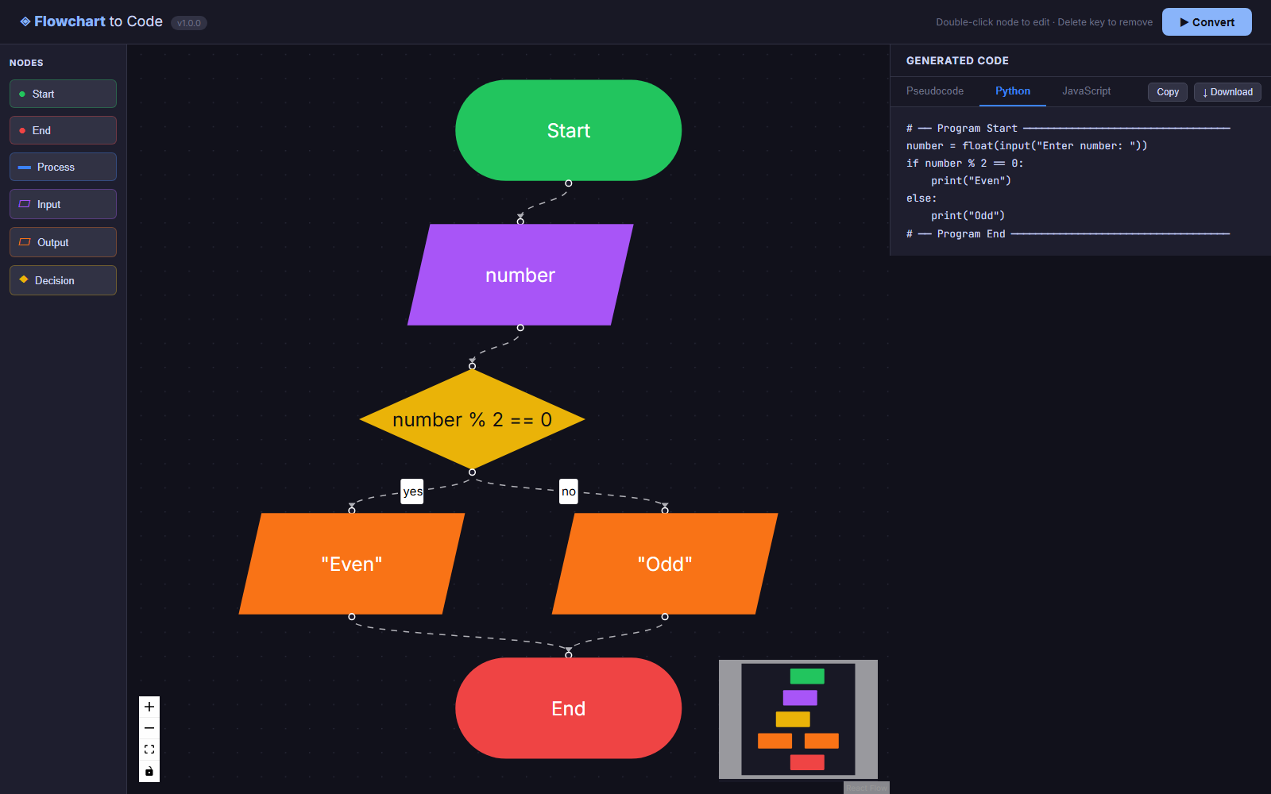
Figure 6. Browser check: PASS. Source: ui-python.png.

JavaScript tab copy and file download
Automated Chromium browser smoke check
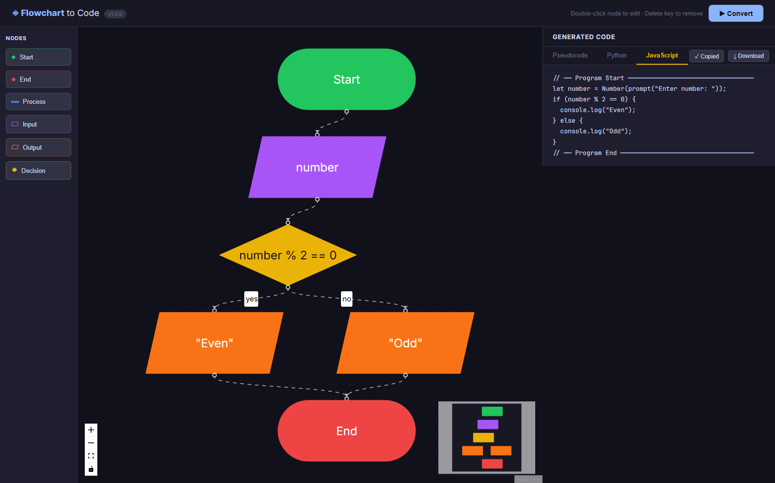
Figure 7. Browser check: PASS. Source: ui-javascript.png.

Edited output label is reflected in regenerated code
Automated Chromium browser smoke check
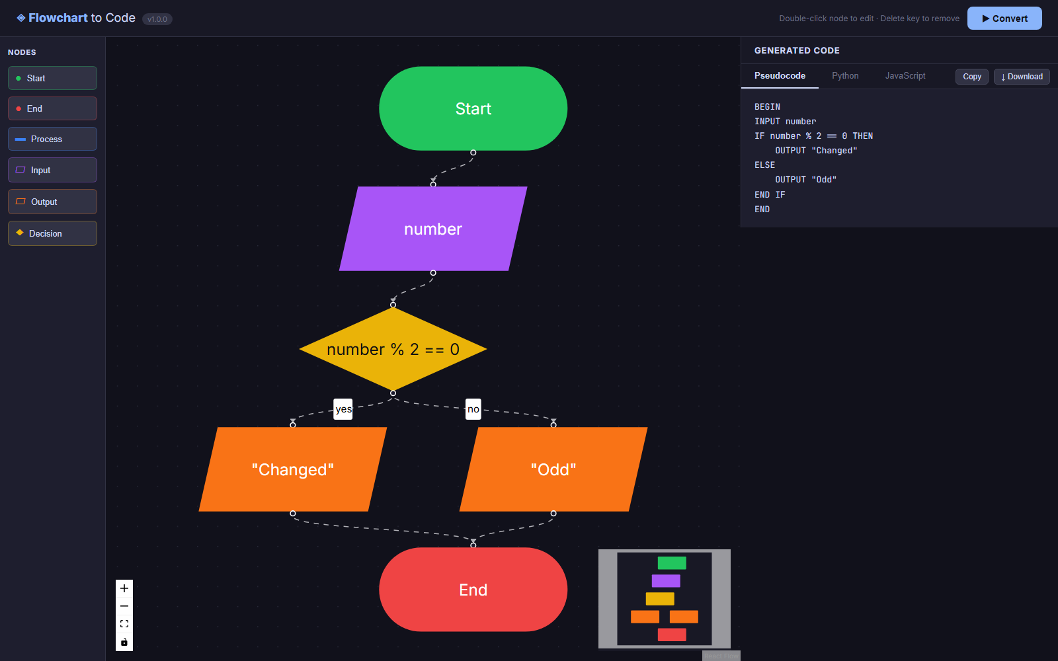
Figure 8. Browser check: PASS. Source: ui-edit.png.

Deleting Start produces an actionable validation message
Automated Chromium browser smoke check
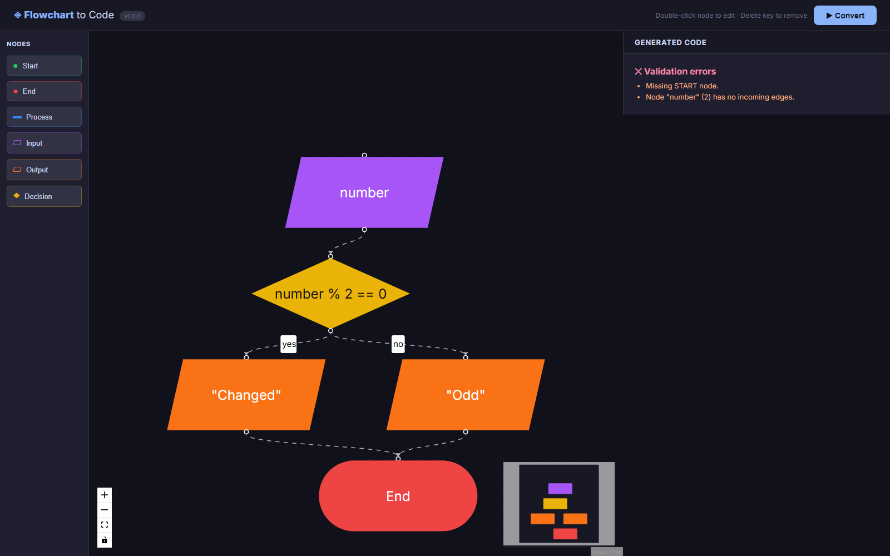
Figure 9. Browser check: PASS. Source: ui-validation.png.

